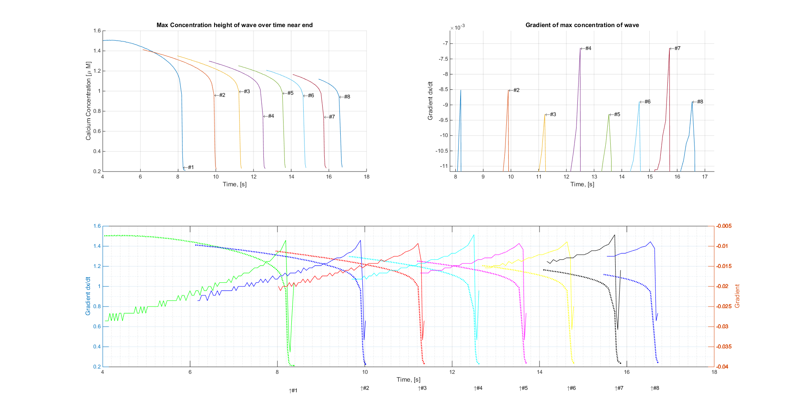Wave near Termination gradient (dx = 1e-3)

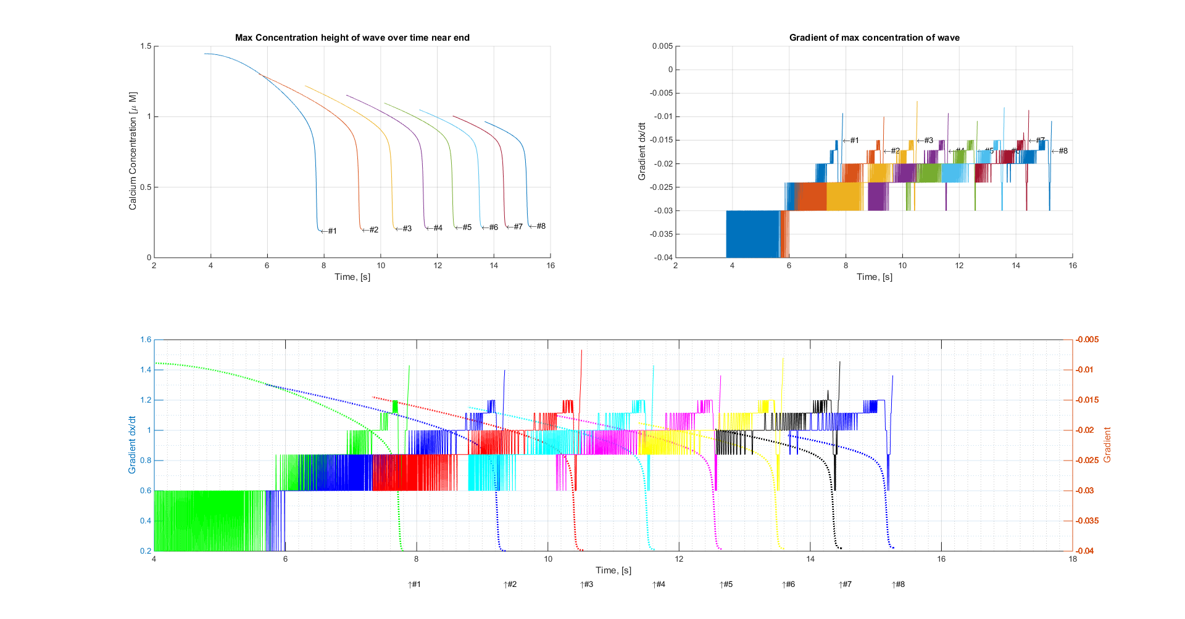(dx = 1e-4)